What is the summer solstice? Here’s what you need to know.

Once a year, an astronomical alignment ushers in this seasonal change that’s celebrated across the world—and shrouded in myth.
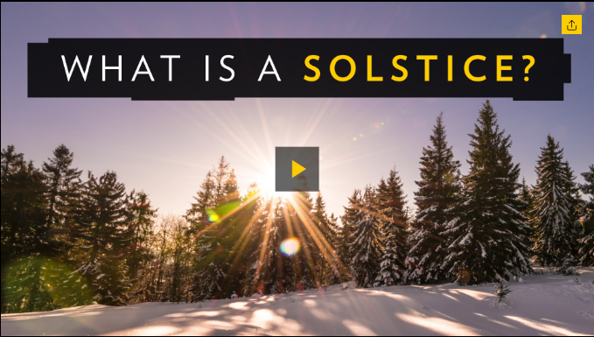
What is the definition of a solstice, and when do they happen? Is the winter solstice always the first day of winter? Find out what causes these biannual astronomical events, as well as how they bring about the shortest and longest days of the year.
Assista ao vídeo em: https://www.nationalgeographic.com/science/space/what-is-summer-winter-solstice-answer-might-surprise-you/

BY MICHAEL GRESHKO

PUBLISHED JUNE 19, 2020
This year, the northern summer solstice falls on June 20 at 5:43 p.m. ET. South of the Equator, this same moment marks the unofficial beginning of winter. Solstices occur at the same time around the world, but their local times vary with time zones.
Traditionally, summer and winter solstices helped mark the changing of the seasons—along with their counterparts, the spring and autumnal equinoxes. However, today’s meteorologists officially use temperature records instead to draw lines between the seasons. So what exactly are solstices—and how have they been celebrated throughout history? Here’s all you need to know.
What are solstices?
Solstices occur because Earth’s axis of rotation is tilted about 23.4 degrees relative to Earth's orbit around the sun. This tilt drives our planet's seasons, as the Northern and Southern Hemispheres get unequal amounts of sunlight over the course of a year. From March to September, the Northern Hemisphere is tilted more toward the sun, driving its spring and summer. From September to March, the Northern Hemisphere is tilted away, so it feels like autumn and winter. The Southern Hemisphere's seasons are reversed.
On two moments each year—what are called solstices—Earth's axis is tilted most closely toward the sun. The hemisphere tilted most toward our home star sees its longest day, while the hemisphere tilted away from the sun sees its longest night. During the Northern Hemisphere’s summer solstice—which always falls around June 21—the Southern Hemisphere gets its winter solstice. Likewise, during the Northern Hemisphere's winter solstice—which falls around December 22—the Southern Hemisphere gets its summer solstice.
You can also think about solstices in terms of where on Earth the sun appears. When it’s a summer solstice in the Northern Hemisphere, the sun appears directly over the Tropic of Cancer, the latitude line at 23.5 degrees North. (That’s as far north as you can go and still see the sun directly overhead.) During the Northern Hemisphere’s winter solstice, the sun appears directly over the Tropic of Capricorn, the Tropic of Cancer’s southern mirror image.
Earth is not the only planet with solstices and equinoxes; any planet with a tilted rotational axis would see them, too. In fact, planetary scientists use solstices and equinoxes to define "seasons" for other planets in our solar system.
It's worth noting, though, that other planets' seasons don't climatically equal those on Earth for a few reasons. First, planets vary in their axial tilts: Venus's axis of rotation is tilted by just three degrees, so there's much less seasonal difference between the Venusian summer and winter solstices than those on Earth. In addition, planets such as Mars have less circular orbits than Earth's, which means that their distances from the sun vary more dramatically than ours do, with correspondingly bigger effects on seasonal temperature.
Earth’s axial tilt plays a much bigger role than its near-circular orbit in governing annual seasons. Earth makes its closest annual approach of the sun about two weeks after the December solstice, during the Northern Hemisphere's winter. Earth is farthest from the sun about two weeks after the June solstice, during the Northern Hemisphere's summer.
The solstice through history
For millennia, cultures around the world have devised ways to celebrate and revere these celestial events—from building structures that align with the solstice to throwing raucous festivals in its honor.
Though the purpose of the enigmatic English structure Stonehenge remains unknown, this 5,000-year-old monument has a famously special relationship with the solstices. On the summer solstice, the complex’s Heel Stone, which stands outside Stonehenge’s main circle, lines up with the rising sun.
In Egypt, the Great Pyramids at Giza appear to be aligned with the sun as well. When viewed from the Sphinx, the sun sets between the pyramids of Khufu and Khafre during the summer solstice—though it remains unclear precisely how the ancient Egyptians oriented it this way.
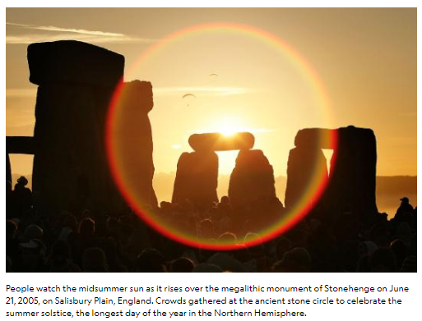
Many cultures have found unique ways to mark the summer solstice. The traditional Scandinavian holiday of Midsummer welcomes it with maypole dancing, drinking, and romance. During the Slavic holiday of Ivan Kupala, people wear floral wreaths and dance around bonfires, while some plucky souls jump over the fires as a way of ensuring good luck and health. In a more modern tradition, the people of Fairbanks, Alaska, swing in the summer solstice with a nighttime baseball game to celebrate the fact that they can get up to 22.5 hours of daylight in the summer. The Midnight Sun Game has been played 115 times now since 1906.
The winter solstice has had its share of celebrations, too. On June 24, in time with the Southern Hemisphere’s winter solstice, the Inca Empire celebrated Inti Raymi, a festival that honored the Inca religion’s powerful sun god Inti and marked the Inca new year. The festival is still celebrated throughout the Andes, and since 1944, a reconstruction of Inti Raymi has been staged in Cusco, Peru, less than two miles from its Inca Empire home. Ancient Romans celebrated the winter solstice with Saturnalia, a seven-day festival that involved giving presents, decorating houses with plants, and lighting candles. And Iranians celebrate Yalda in December. The festival—a mainstay since Zoroastrianism was Iran’s dominant religion—traditionally honors the birth of Mithra, the ancient Persian goddess of light.
Misconceptions about the solstices
If solstices mark the brightest and darkest days of the year, why don’t temperatures reflect that?
In short, it’s because it takes time for Earth’s land and water to heat up and cool down. In the U.S., the year’s coldest temperatures set in after-mid January, roughly a month after the Northern Hemisphere’s winter solstice. Likewise, thermometers hit their high in the U.S. in July and August, weeks after the summer solstice.
Some believe, too, that since Earth’s rotation is slowing down, each new solstice sets a new record for daytime length. But that’s not the case.
It’s certainly true that Earth’s rotation has slowed over billions of years, as Earth loses angular momentum to our planet’s tides. Growth lines on fossil corals show that more than 400 million years ago, days on Earth lasted less than 22 hours.
But Earth’s gradual slowing down isn’t the only factor at play. Picture a figure skater twirling on their skates; they can speed up or slow down their twirls by how much they tuck in their limbs. In much the same way, changes in the distribution of Earth’s mass—from the winds of El Niño to the melting of Greenland’s ice—can subtly tweak our planet’s rotation rate.

Proposta:
Leia o texto todo, sem se preocupar em traduzi-lo. Basta que você entenda o conteúdo.
Responda as seguintes questões:
1. O que são solstícios?
2. Escreva um fato histórico sobre o solstício.
3. O solstício coincide com o início das estações inverno/verão?

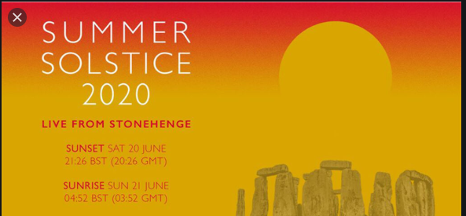
https://www.youtube.com/watch?v=2EZ5cLVOako

