english homework viii
KET

1. Play KAHOOT!
https://kahoot.it/challenge/08746991?challenge-id=823cd869-e490-4260-a8e1-ca06aafd6103_1593723096908
How many questions did you answer correctly?

2. Name the chores below.
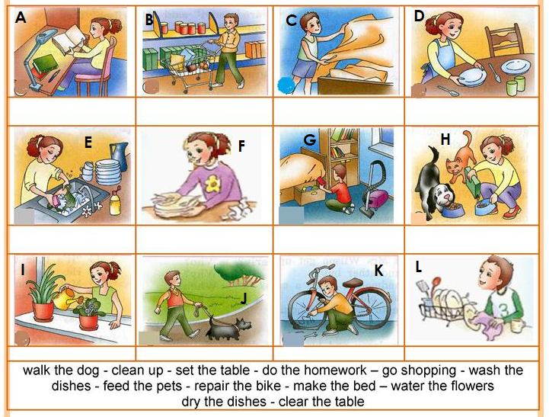
a) _________________________ g) _________________________
b) _________________________ h) _________________________
c) _________________________ i) _________________________
d) _________________________ j) _________________________
e) _________________________ k) _________________________
f) _________________________ l) _________________________

