english homework Iv
PET

1. Rewrite the sentences below using the Passive form without the subject.
You can re-watch the video from this morning’s activity if you need to.

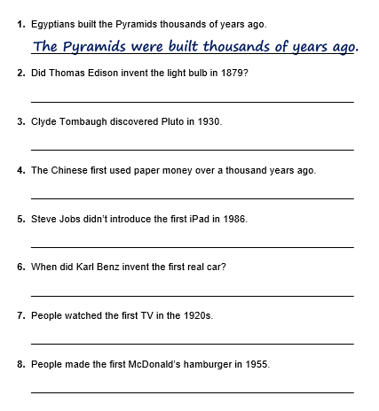

2. Now, create three examples from your own experience of active to passive voice.
__________________________________________________________________________
__________________________________________________________________________
__________________________________________________________________________
__________________________________________________________________________
__________________________________________________________________________
__________________________________________________________________________
__________________________________________________________________________

