english homework Ii
KET
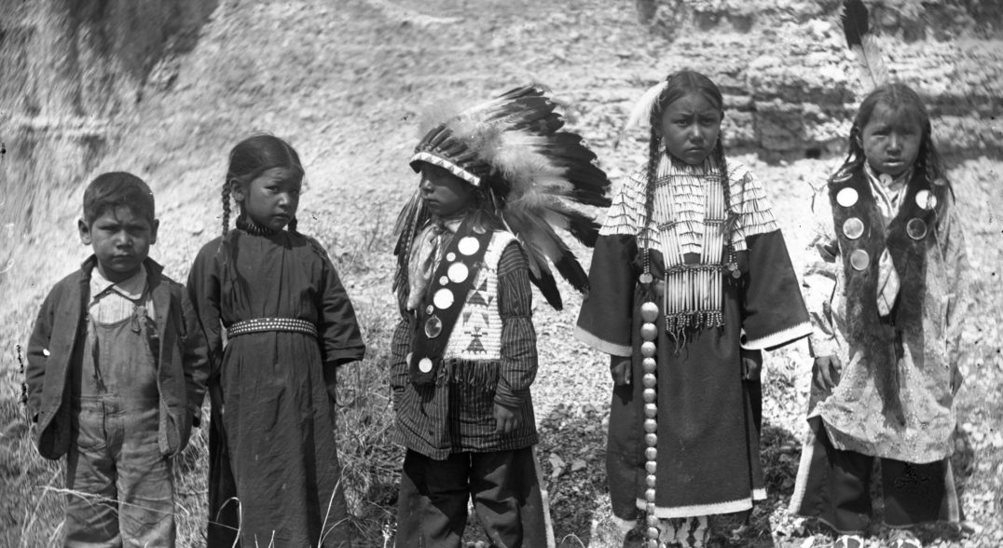
“Indigenous Peoples' Day is a holiday that celebrates and honors Native American peoples and commemorates their histories and cultures. It is celebrated across the United States on the second Monday in October, and is an official city and state holiday in various localities.”

1. Assista ao vídeo e ilustre as seguintes palavras:
https://www.youtube.com/watch?v=uxNDKlh-Vjo

Plankhouse Teepee

Cotton Basket

Shoes Deer

