english homework Ii
PET
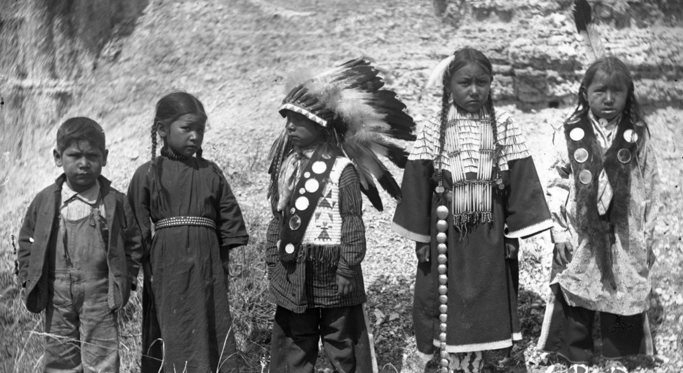
“Indigenous Peoples' Day is a holiday that celebrates and honors Native American peoples and commemorates their histories and cultures. It is celebrated across the United States on the second Monday in October, and is an official city and state holiday in various localities.”

1. Watch the following video and choose one aspect of Native Americans’ lives to explore: https://www.youtube.com/watch?v=uxNDKlh-Vjo

2. We are going to create a JAMBOARD together.
Go to https://jamboard.google.com/d/1y5LR-84P8LFrIZTDO_SSbWsMwGl4crb4h-FTWJh5e30/edit?usp=sharing and use the frame with your name on it to post descriptions and pictures related to the topic you chose on #1.

Use these websites to find more information:
https://kids.nationalgeographic.com/explore/native-americans/
https://www.britannica.com/topic/Native-American

