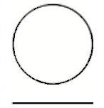
água na lua
Questão 1
Antares (Alfa Scorpii ou Alfa do Escorpião) é a estrela mais brilhante da constelação do Escorpião e uma das 20 estrelas mais brilhante do céu. Ela tem um diâmetro de cerca de 900 vezes (Baade, R. & Reimers, D., Astronomy and Astrophysics 474 (1): 229–237, 2007) o diâmetro do Sol e é uma Supergigante Vermelha. Veja ilustração abaixo comparando Antares e o Sol, quase em escala, pois o Sol está maior do que deveria estar.
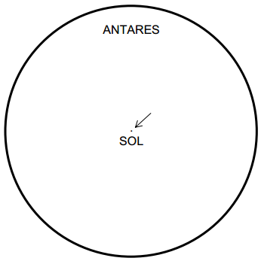
Pergunta
1a) Se colocada na posição do Sol, Antares, por seu tamanho, envolveria até além da órbita de Marte. Considerando o diâmetro do Sol como sendo de 1.400.000 km e sabendo que 1 Unidade Astronômica (U.A.) = 150.000.000 km, calcule o diâmetro da estrela Antares em U.A. Atenção: É necessário explicitar as contas.
1b) Calcule quantas estrelas iguais ao Sol cabem dentro de Antares. Atenção: Evite contas desnecessárias! Faça uma única razão: Volume de Antares dividido pelo Volume do Sol.

Questão 2
Space station Mir remained in orbit for 15 years and circled Earth some 86 500 times during its time in space. The longest stay of one cosmonaut in the Mir was around 680 days.
Approximately how many times did this cosmonaut fly around Earth? Explain your answer.
- 110
- 1 100
- 11 000
- 110 000

Questão 3
On 8 June 2004, the planet Venus could be seen passing in front of the Sun when viewed from many places on Earth. This is called a “transit” of Venus and happens when its orbit takes Venus between the Sun and Earth. The previous transit of Venus occurred in 1882 and another is predicted to occur in 2012. Below is a picture of the transit of Venus in 2004. A telescope was pointed at the Sun and the image projected onto a white card.
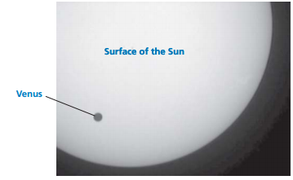
3a) Why was the transit observed by projecting the image onto a white card, rather than by looking directly through the telescope? Explain your answer.
(A) The Sun’s light was too bright for Venus to show up.
(B) The Sun is big enough to see without magnification.
(C) Viewing the Sun through a telescope may damage your eyes.
(D) The image needed to be made smaller by projecting it onto a card.

3b) When viewed from Earth, which one of the following planets can be seen in transit across the face of the Sun at certain times?
- Mercury
- Mars
(C) Jupiter
(D) Saturn

Questão 4
Several words have been underlined in the following statement.
Astronomers predict that, as seen from Neptune, there will be a transit of Saturn across the Sun’s face later this century.
Which three of the underlined words would be most useful in an internet or library search to find out when this transit might occur? Why?

Questão 5
Map to Mystery
