"#DevilComeback"
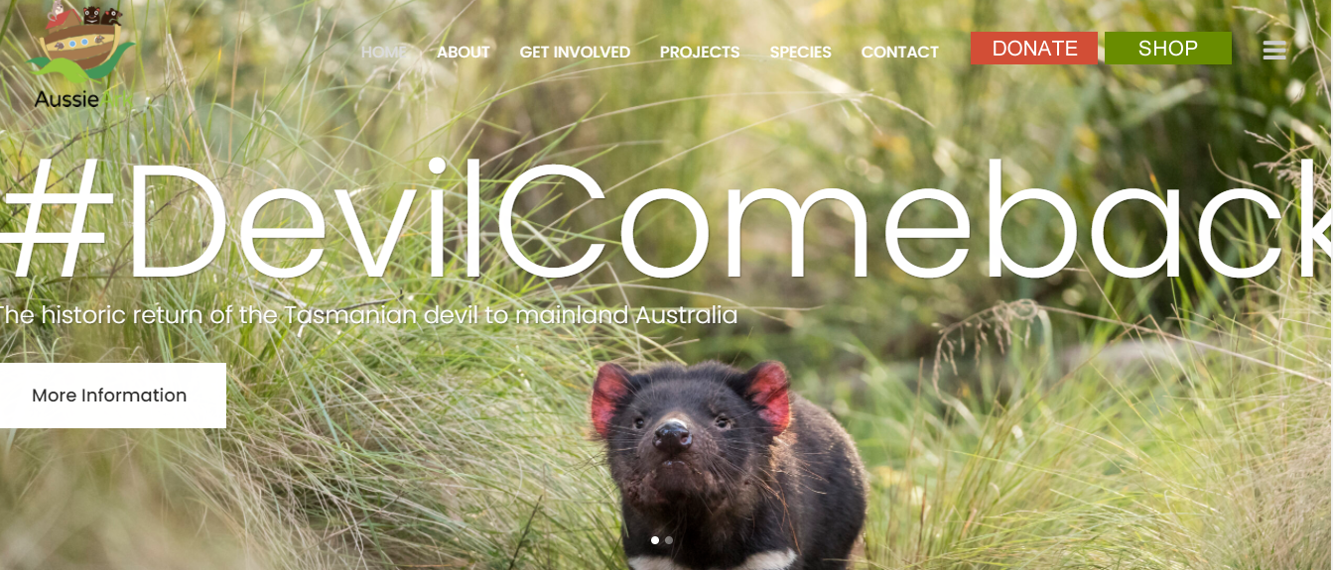

The #DevilComeback is a historic effort to return the iconic Tasmanian Devil to mainland Australia for the first time in 3,000 years through the collaborative work of Aussie Ark, Global Wildlife Conservation and Wild Ark.
This first historic release is only step one in our mission to rewild Australia and bring balance to the bush. Aussie Ark and our partners are committed to returning Australia’s ecosystems to that of pre European settlement, free from introduced feral predators – an island oasis. We need YOUR help. Aussie Ark relies solely on donation of funds to be able to restore Australia’s ecosystems, without you Aussie Ark cannot continue to deliver brighter futures for Australian native wildlife.
Aussie Ark have worked tirelessly over the past decade to build an insurance population of the endangered species. To date, more than 390 devils have been born and raised at Aussie Ark in a way that fosters natural behaviour in the animals, preparing them for release into the wild. Aussie Arks ‘Rewild Australia’ strategy is a key component, alongside Species and habitat recovery, in returning Australia to it pre-European state.

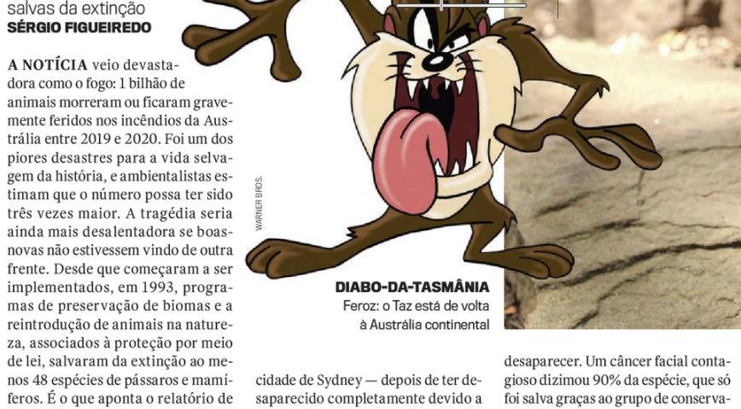
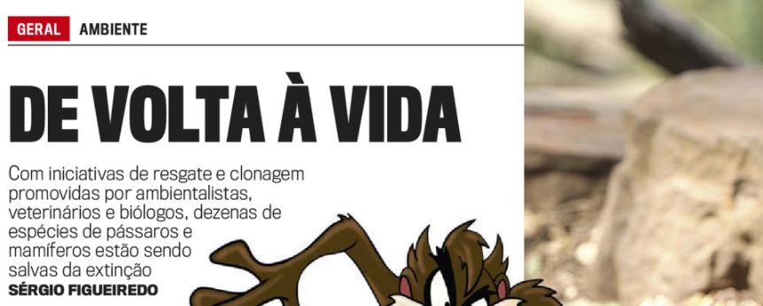

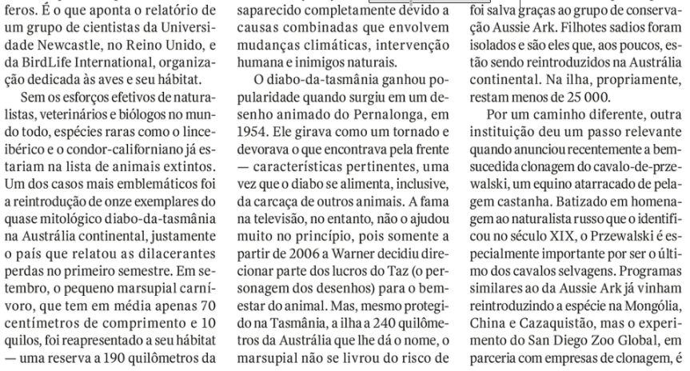

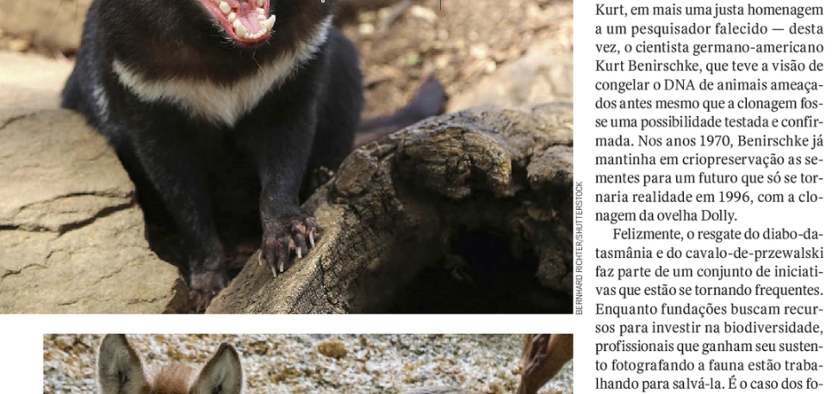
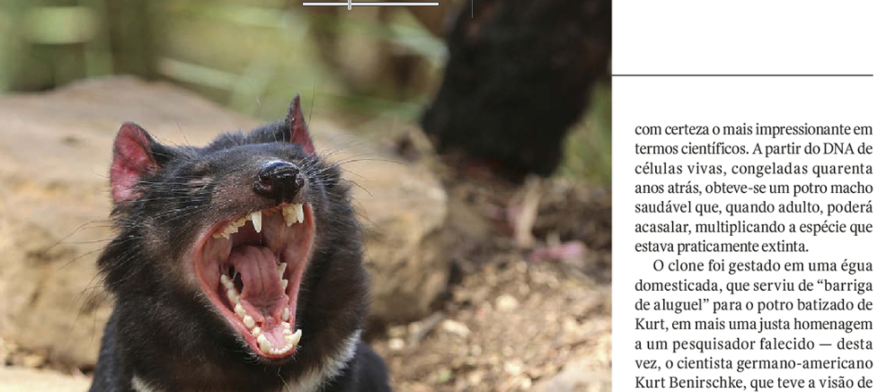

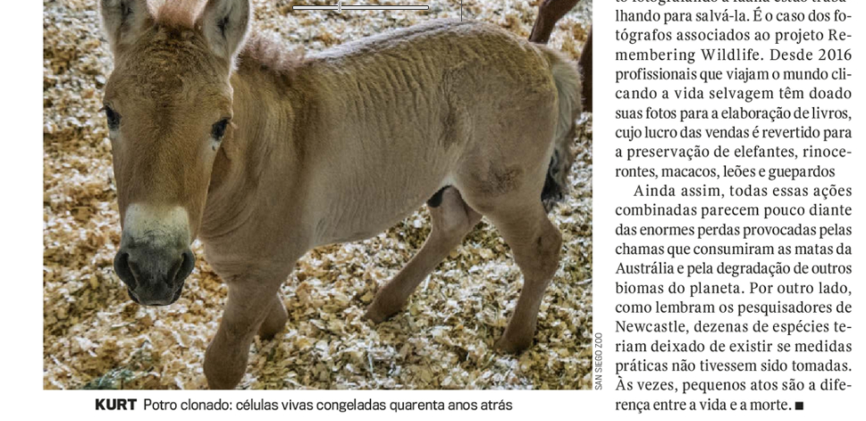

PROPOSTA:
Após a leitura dos textos:
1. Escreva um resumo da parte introdutória: “Devil Comeback”.
2. Escreva 10 palavras-chave de cada parágrafo da reportagem da revista Veja: De Volta à Vida.

resumo de “Devil Comeback”
DE VOLTA À VIDA
parágrafo 1
parágrafo 2
parágrafo 3
parágrafo 4
parágrafo 5
parágrafo 6
parágrafo 7

